**Assignment – 14**

Name- Yashraj Ranjeet Shitole

Roll no. - 86633

1) Write a command that puts the following values, in their given order, into the salespeople table: city – San Jose, name – Blanco, comm – NULL, snum – 1100.

Insert into salespeople(city,name,comm,snum) values(‘San Jose’,’Blanco’,null,’1100’);



2) Write a command that removes all orders from customer Clemens from the Orders table.

delete from orders where cnum=(SELECT cnum FROM customers where cname='Clemens');

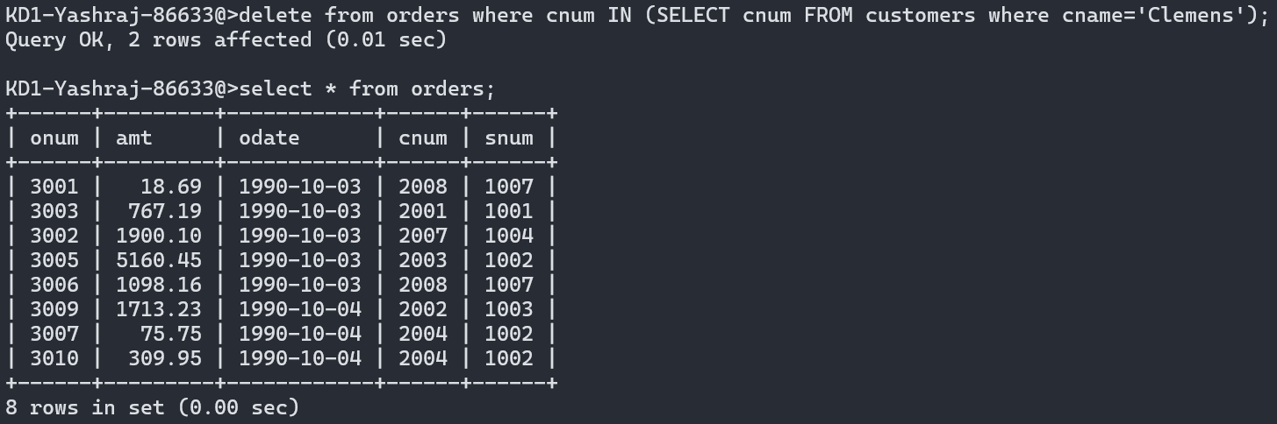

3) Write a command that increases the rating of all customers in Rome by 100.

**update customers set rating=(rating+100) where city='Rome';**

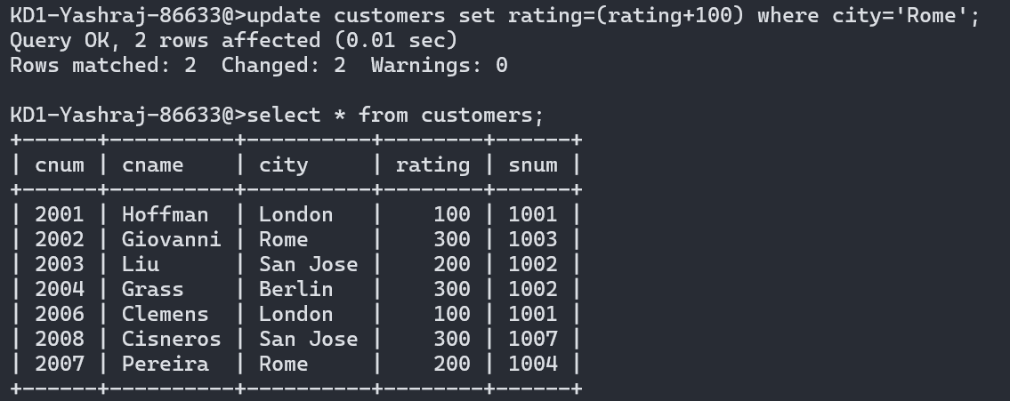

4) Salesperson Serres has left the company. Assign her customers to Motika.

Update

**update customers set snum=(select snum from salespeople where sname='Motika') where customers.snum=(select salespeople.snum from salespeople where sname='Serres');**

